

STARTERS

1. Chicken Satay  สะเต๊ะไก่ £4.95
Thin strips of chicken marinated in spices, skewered, grilled on charcoal.
(Served with peanut sauce

2. Chicken Toast ขนมปังหน้าไก่ £4.95
Toast topping with mince chicken and sesame seed

3. Crispy Fried Wonton เกี๊ยวทอด£4.95
Deep-fried wonton with minced chicken. (Served with sweet chilli sauce)

4. Chicken Spring Rolls ปอเปี๊ยะไก่ £4.95
Deep-fried spring rolls stuffed with a mixture of minced chicken, vermicelli and vegetables. (Served with sweet chilli sauce)

5. Pork Ribs 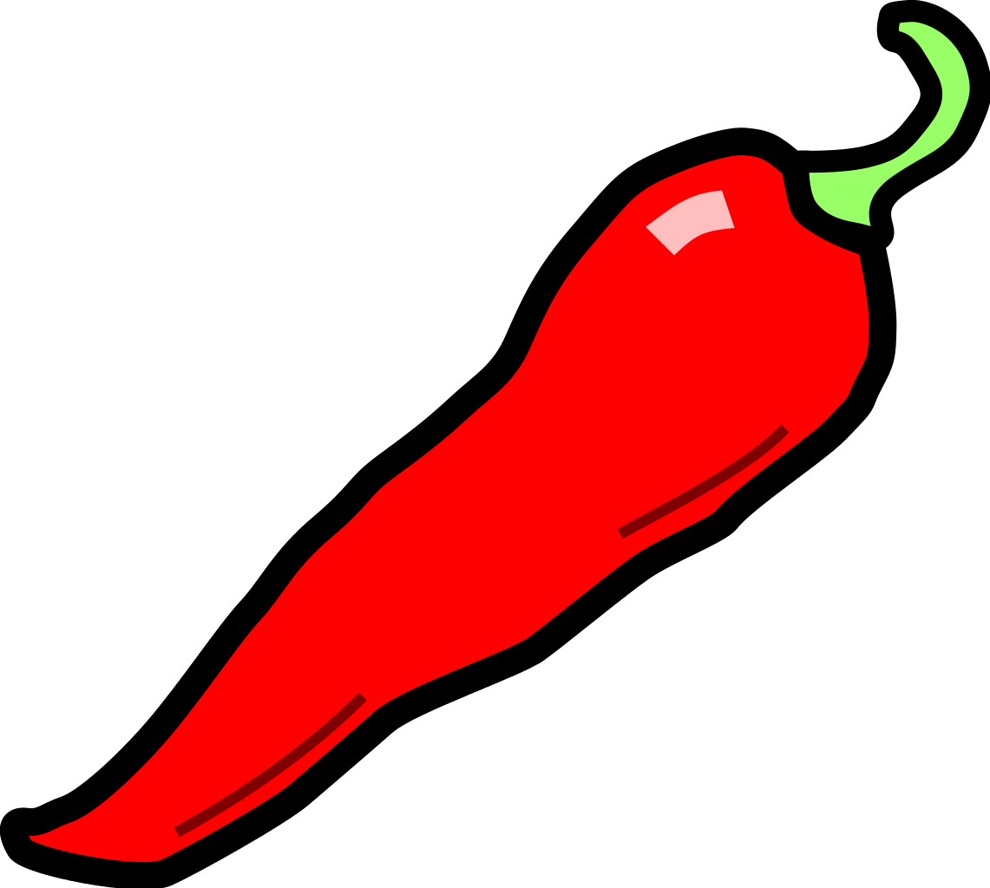 ซี่โครงหมูทอด £4.95
Deep-fried marinated pork spare ribs with Thai herbs and ground peppers.
(Served with sweet chilli sauce)

6. Thai Fish Cakes ทอดมัน£5.50
Deep-fried minced fish with green beans and Thai spices.
(Served with sweet chilli sauce,

7. Gai Choop Pang ไก่ชุบแป้งทอด £4.95
Chicken in batter. (Served with sweet chilli sauce)

8. Goong Tempura กุ้งเทมปุระ £5.50
Deep-fried prawns and vegetables in batter. (Served with sweet chilli sauce)

9. Sai Krok Isan ไส้กรอกอีสาน £5.50
Northeastern style sour sausage served alongside with chillies, ginger and peanuts

10. Special Hors d’Oeuvres
รวมมิตรสตาร์ทเตอร์ £13.95
Chef’s choice of starters, including chicken satay, chicken spring rolls, crispy fried wonton, chicken on toasts and pork ribs. (For 2 People)

11. Thai Prawn Crackers ข้าวเกรียบ£2.95

12. Satay Hed (V)  สะเต๊ะเห็ด £4.95
Mushrooms marinated in spices, skewered, grilled on charcoal.
(Served with peanut sauce and pickled vegetable)

13. Pak Tod (V) ผักทอด £4.95
Deep-fried mixture of vegetables in batter. (Served with sweet chilli sauce)

14. Veg Spring Rolls (V) ปอเปี๊ยะเจ £4.95
Deep- spring rolls stuffed with mixture of vermicelli and vegetables.
(Served with sweet chilli sauce)

15. Yum Tofu (V) ยำเต้าหู้สด £4.95
Sauté tofu mixed with chili powder, lemon juice, spring onions, ginger and peanuts, served on lettuce

SOUPS

16. Tom Yum Chicken or Prawns ต้มยำไก่ หรือ กุ้ง £4.95
Chicken or prawns in a spicy hot and sour lemongrass soup with mushrooms. (Clear soup)

17. Tom Kha Chicken or Prawns
ต้มข่าไก่ หรือ กุ้ง £4.95
Chicken or prawns in a soup flavoured with coconut milk, lemon juice, galangal and mushrooms.

18. Tom Poh Taek ต้มโป๊ะแตก£5.95
Mixed seafood in a spicy hot and sour lemongrass soup with mushrooms.
(Clear soup)

19. TomYum Tofu (V) ต้มยำเต้าหู้£4.95
Tofu in a spicy hot and sour lemongrass soup with mushrooms. (Clear soup)

20. Tom Kha Tofu (V) ต้มข่าเต้าหู้£4.95
Tofu in a soup flavoured with coconut milk, lemon juice, galangal and mushrooms.

MAIN COURSES
Choose from a selection of Meat or Vegetables (not include rice)

CHICKEN, PORK or BEEF £8.95
LAMB, DUCK or PRAWN £9.95
VEGETABLE or TOFU £7.95

21. Gang Pa (Jungle Curry) แกงป่า Curry Paste cooked in clear soup with Thai herbs and vegetables. (No coconut milk is mixed)

22. Gang Ped (Red or Green Curry) แกงแดง/แกงเขียวหวาน
Red or green curry paste cooked with coconut milk, bamboo shoots and Thai herbs.

23. Gang Matsaman แกงมัสมั่น
Creamy curry paste cooked with coconut milk, peanuts, potatoes, red and green peppers pineapple and Thai herbs.

24. Gang Panang แกงพะแนง
Thick and Creamy curry cooked with aromatic panang curry paste, coconut milk, lime leaves and green beans.

25. Pad Ped Nor Mai ผัดเผ็ดหน่อไม้
Stir-fried special red curry paste with bamboo shoots and lime leaves.

26. Pad Prig ผัดพริก
Stir-fried with fresh chilli, garlic, spring onions and onions.

27. Pad Ga-Prao
ผัดกะเพรา
Stir-fried with fresh chillies and basil leaves. (MEAT ARE MINCED)

28. Pad Khing ผัดขิง
Stir-fried with fresh mushrooms and ginger.

29. Pad Gra-Tiem Prig Thai
ผัดกระเทียมพริกไทย
Stir-fried with garlic, Thai sauce and ground peppers.

30. Pad Med-Ma-Muang Him-Ma-Parn ผัดเม็ดมะม่วงหิมพานต์
Stir-fried with cashew nuts in a sweet sauce with mild chilli oil and pineapple.

31. Pad Preaw Wan ผัดเปรี้ยวหวาน
Stir-fried with Thai sweet & sour sauce, red and green peppers, cucumber and tomato.

32. Pad Num Mon Hoy ผัดน้ำมันหอย
Stir-fried with oyster sauce, red and green peppers and fresh mushrooms.

SPECIAL DISHES

33. Khao Niao & Moo Yang £9.95
ข้าวเหนียวหมูย่าง
Marinated grilled pork on skewers served with steamed sticky rice.

34. Tom Saep Pork or Beef
ต้มแซ่บหมู/เนื้อ £9.95
Stewed pork or beef in a hot and spicy soup.

35. Khai Yiao Ma Ga-Prao Krob ไข่เยี่ยวม้ากะเพรากรอบ £9.95
Stir-fried preserved eggs with minced pork, fresh chillies and crispy basil leaves

36. Pad Poh Taek £9.95
ผัดโป๊ะแตก
Stir-fried mixed seafood with special spicy sauce, pounded garlic and fresh chillies

37. Gang Phed Ped Yang £9.95
แกงเผ็ดเป็ดย่าง
Special Roast Duck in red curry paste with coconut milk, tomatoes, pineapple and herbs.

38. Goong Pad Saam Sahai £9.95
กุ้งผัดสามสหาย
Stir-fried king prawns with baby corn, mange tout, fresh mushrooms, crushed garlic and soya sauce.

39. Goong Chae Nam Pla (Raw Prawns) กุ้งแช่น้ำปล £10.95
Raw king prawns topped with garlic, chillies, fish sauce and lime juice.
(Served at room temperature)

40. Goong Ohp Wun Sen £10.95
กุ้งอบวุ้นเส้น
King prawns and glass noodles steamed with Thai herbs. (Served in a hotpot)

41. Goong Shu Shi £9.95
กุ้งฉู่ฉี่
King Prawns cooked with special curry paste, coconut milk and lime leaves.

FISH
Fish sizes may vary slightly each season

42. Sea bass Lard Prig £15.95ปลาราดพริก
Deep-fried whole seabass coated in chilli and tamarind sauce.

43. Sea bass Shu Shi £15.95
ปลาฉู่ฉี่
Deep-fried whole seabass cooked with special curry paste, coconut milk and lime leaves.

44. Sea bass Nueng Ma-Nao ปลานึ่งมะนาว £15.95
Steamed whole seabass with garlic, fresh chillies, fresh lime juice and fish sauce.

45. Sea bass Pae-Sa £15.95
ปลาแป๊ะซะ
Deep-fried whole seabass with chillies, tamarind sauce and vegetables.
(Soup based)

46. Sea bass Yum ยำปลา£15.95
Deep-fried seabass fillet with spicy salad. (Raw mango, chillies, lemongrass, lemon juice, spring onions, coriander, shallots and cashew nuts)

SIZZLING DISHES
All dishes are served on a sizzling plate

47. Weeping Tiger £11.95
เสือร้องไห้
Grilled marinated sirloin steak. (Served with special spicy sauce)

48. Gae Yang (Lamb) £11.95
แกะย่าง
Grilled marinated fillet of lamb. (Served with special spicy sauce)

THAI SALADS
Served at Room Temperature

49. Seafood Yum Wun Sen £9.95
ยำวุ้นเส้นทะเล
Glass noodles with mixed seafood, lemon juice, chillies, shallots, coriander and spring onions.

50. Yum Wun Sen Chicken or Pork ยำวุ้นเส้นไก่/หมู £8 95
Glass noodles with minced chicken or pork, lemon juice, chillies, shallots, coriander and spring onions.

51. Nam Tok Neua £9.95
น้ำตกเนื้อ
Thinly sliced hot and sour sirloin steak grilled on charcoal, mixed with chilli powder, lemon juice and spring onions, served on lettuce.

52. Yum Phed Yang £9.95
ยำเป็ดย่าง
Thinly sliced hot and sour roast duck, mixed with chillies, spring onions and lemon juice.

53. Seafood Yum £9.95
ยำทะเล
Mixed seafood mixed with lemon juice, fresh chillies shallots, coriander and spring onions.

54. Pla Goong £9.95
พล่ากุ้ง
Prawns seasoned with lemon juice, lemongrass, shallots, spring onions, chilli and coriander.

55. Som Tum & Gai Yang £9.95
ส้มตำไก่ย่าง
Papaya salad mixed with carrots, fine beans, fresh chillies, garlic, lime juice, tomatoes, fish sauce and ground peanuts, served alongside with grilled chicken.

56. Larb Chicken or Pork £8.95
ลาบไก่/หมู
Cooked minced chicken or pork with chilli powder, lemon juice and spring onions.

57. Nam Tok Moo £9.95
น้ำตกหมู
Thinly sliced grilled pork on charcoal, mixed with chilli powder, lemon juice and spring onions, served on lettuce.

NOODLE AND RICE DISHES

58. Pad Thai Chicken, Pork or Beef ผัดไทยไก่/หมู/เนื้อ £8.95
Stir-fried rice noodles with chicken, pork or beef, eggs, bean sprouts, peanuts and tamarind sauce.

59. Pad Thai Prawns £9.95
ผัดไทยกุ้ง
Stir-fried rice noodles with prawns, eggs, bean sprouts, peanuts and tamarind sauce.

60. Pad Kua Chicken £8.95
ก๋วยเตี๋ยวคั่วไก่
Stir-fried thick noodles with chicken, spring onions, eggs and preserved vegetables.

61. Pad Kee Mao Chicken, Pork or Beef £8.95
ผัดขี้เมาไก่/หมู/เนื้อ
Drunken stir-fried thick noodles with chicken, pork or beef, basil, fresh chilli and vegetables.

62. Pad Kee Mao Prawns  ผัดขี้เมากุ้ง £9.95
Drunken stir-fried thick noodles with prawns, basil, fresh chillies and
vegetables.

63. Pad Si Aew Chicken, Pork or Beef ผัดซีอิ๊วไก่/หมู/เนื้อ £8.95
Stir-fried thick noodles with chicken, pork or beef with eggs, vegetables and dark soy sauce.

64. Pad Si Aew Prawns £8.95
ผัดซีอิ๊วกุ้ง
Stir-fried thick noodles with prawns, eggs, vegetables and dark soy sauce.

65. Raat Na Chicken, Pork or Beef ราดหน้าไก่/หมู/เนื้อ £8.95
Stir-fried thick noodles in thick creamy sauce with soy sauce, vegetables, topped with choice of meat.

66. Raat Na Seafood £9.95
ราดหน้าทะเล
Stir-fried thick noodles in thick creamy sauce with soy sauce, vegetables, topped with mixed seafood.

67. Suki Chicken, Pork or Beef
สุกี้แห้ง/น้ำไก่/หมู/เนื้อ £8.95
Choice of meat with glass noodles in a Thai-style Suki sauce, either stir-fried (dry) or in stock soup.

68. Suki Seafood £9.95
สุกี้แห้ง/น้ำ ทะเล
Prawns with glass noodles in a Thai-style Suki sauce, either stir-fried (dry) or in stock soup.

69. Seafood Yen Ta Fo £9.95
เย็นตาโฟทะเล
Noodles with seafood and fish balls in pink stock soup, served with crispy wonton.

70. Kuay Dtiaao Neua/Moo Dtoon ก๋วยเตี๋ยวเนื้อ/หมูตุ๋น £8.95
Beef or pork stew soup with noodles. (With Beef/Pork balls)

71. Kuay Dtiaao Tom Yum Moo-Sup ก๋วยเตี๋ยวต้มยำหมูสับ £8.95
Minced and Stewed Pork in chilli and fresh lemon juice soup with noodles.

72. Tom Yum Chicken/Prawn with Noodles £8.95 / £8.95ต้มยำไก่/กุ้งใส่เส้นก๋วยเตี๋ยว
Chicken or Prawn in a spicy hot and sour Tom Yum soup with noodles.

73. Khao Kaa Moo £8.95
ข้าวขาหมู
Stewed pork leg served with rice, boiled egg and special dipping sauce.

74. Khao pad gapi Chicken £8.95
,ข้าวผัดกะปิ ,.
Fried rice

75. Khao Man Gai (Hainanese Chicken Rice) £8.95
ข้าวมันไก่
Chicken with garlic and ginger rice served with cucumber and special soybean sauce.

76. Pad Ga-Prao Chicken/Pork/Beef with Rice £8.95ผัดกะเพราไก่/หมู/เนื้อราดข้าว
Stir-fried choice of minced meat with basil leaves, chillies, served with rice

77. Pad Ga-Prao Seafood with Rice £9.95
ผัดกะเพราทะเลราดข้าว
Stir-fried mixed seafood with basil leaves, chillies, served with rice

78. Khao Pad Chicken, Pork or Beef ข้าวผัดไก่/หมู/เนื้อ £8.95
Fried rice with choice of meat, eggs and vegetables.

79. Khao Pad with Seafood £9.95
ข้าวผัดทะเล
Fried rice with mixed seafood, eggs and vegetables.

80. Khao Pad Puu (Crab Meat Fried Rice) ข้าวผัดปู £9.95
Fried rice with crab meat, eggs and vegetables.

SIDE DISHES

81. Pad Pak Pasom ผัดผักผสม£4.95
Stir-fried mixed vegetables with oyster sauce

82. Pad Broccoli ผัดบรอกโคลี£5.95
Stir-fried broccoli with oyster sauce

83. Pad Pak Sum Sahai ผัดผักสามสหาย £5.95
Stir-fried vegetables, including baby corn, mange tout and fresh mushrooms with soya sauce.

84. Plain Pad Thai  ผัดไทยเปล่า£5.95
Stir-fried vermicelli noodles with eggs, bean sprouts and peanuts.

85. Jasmine Rice ข้าวสวย £2.50

86. Egg Fried Rice ข้าวผัดไข่ £2.95

87. Sticky Rice ข้าวเหนียว £2.95

88. Coconut Rice ข้าวกะทิ £2.95

89. Garlic & Ginger Rice ข้าวมัน£2.95
90. Chips มันฝรั่งทอด £2.50
HAPPY HOUR MENU £9.95  12.00 - 17.00 hrs EVERYDAY  Starter + Main Course + Rice or Chips  Choose your favourite starter, then meat for your main course and your choice of jasmine rice or chips. All food is served in one dish  Starter  1. Chicken Satay   Thin strips of chicken marinated in spices, skewered and then grilled on charcoal.  (Served with peanut sauce)  2. Satay Hed (Mushroom) (V)  Mushrooms marinated in spices, skewered and then grilled on charcoal.  3. Chicken Spring Rolls  Deep-fried spring rolls stuffed with a mixture of minced chicken, glass noodles and vegetables.  (Served with sweet chilli sauce)  4. Vegetable Spring Rolls (V)  Deep-fried spring rolls stuffed with a mixture of glass noodles and vegetables.  (Served with sweet chilli sauce)  5. Spicy Pork Spare Ribs  Deep-fried marinated pork spare ribs with Thai herbs and ground peppers.  (Served with sweet chilli sauce)  6. Pak Tod (V)  Deep-fried mixture of vegetables in batter. (Served with sweet chilli sauce) | 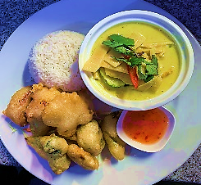  Main Course    7. Thai Red or Green Curry  Red or green curry paste cooked with coconut milk, bamboo shoots and Thai herbs.  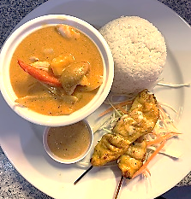  8. Gaeng Massaman  Creamy curry paste cooked with coconut milk, peanuts, potatoes, peppers, pineapple and Thai herbs.  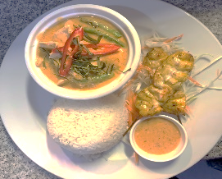  9. Gaeng Panang  Thick and creamy curry cooked with panang curry paste,coconut milk, lime leaves and green beans.  10. Pad Ped Nor Mai  Stir-fried red curry paste with bamboo shoots and lime leaves.  11. Pad Gra-Prao  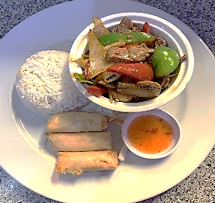  Stir-fried fresh chilli, garlic and basil leaves.  (Meat are minced)  12. Pad Khing  Stir-fried fresh mushrooms and ginger.  13. Pad Preaw Wan  Stir-fried Thai sweet and sour sauce, peppers, cucumbers and tomatoes.  14. Pad Num Mon Hoy  Stir-fried oyster sauce, peppers and mushrooms.  15. Pad Thai  Stir-fried rice noodles with Pad Thai sauce, egg, bean sprouts and peanuts.  (This dish does not include any side dishes)

Mild-Medium Peanut
Medium Vegetarian (V)
Hot

***We have a 50p charge per container used for food needing to take home.

If you have any special dietary requirements, please speak to a manager. Please be aware that as we sell nuts and fish, there may be traces of nuts and fish bones in our products. Our vegetarian option contains no meat or meat products, and aim to prevent them contacting in our dishes in any way

THAI AROI DEE
RESTAURANT
Open seven days a week
12.00-22.30

Tel. 01132452174
120-122 Vicar Lane, Leeds LS2 7NL
www.Thaiaroydeeleeds.com

Main Course

Section of meats

Chicken, Beef or Pork
Tofu or Vegetables

7. Thai Red or Green Curry
Red or green curry paste cooked with coconut milk, bamboo shoots and Thai herbs.

8. Gaeng Massaman
Creamy curry paste cooked with coconut milk, peanuts, potatoes, peppers, pineapple and Thai herbs.

9. Gaeng Panang
Thick and creamy curry cooked with panang curry paste,coconut milk, lime leaves and green beans.

10. Pad Ped Nor Mai
Stir-fried red curry paste with bamboo shoots and lime leaves.

11. Pad Gra-Prao
Stir-fried fresh chilli, garlic and basil leaves. (Meat are minced)

12. Pad Khing
Stir-fried fresh mushrooms and
ginger.

13. Pad Preaw Wan
Stir-fried Thai sweet and sour sauce, peppers, cucumbers and tomatoes.

14. Pad Num Mon Hoy
Stir-fried oyster sauce, peppers and mushrooms.

15. Pad Thai 
Stir-fried rice noodles with Pad Thai sauce, egg, bean sprouts and peanuts.
(This dish does not include any side dishes)

Side Dishes

Jasmine Rice
Chips

